**SPRING REST USING SPRING BOOT 3**

**1. Create a Spring Web Project using Maven:  
  
Step 1:**

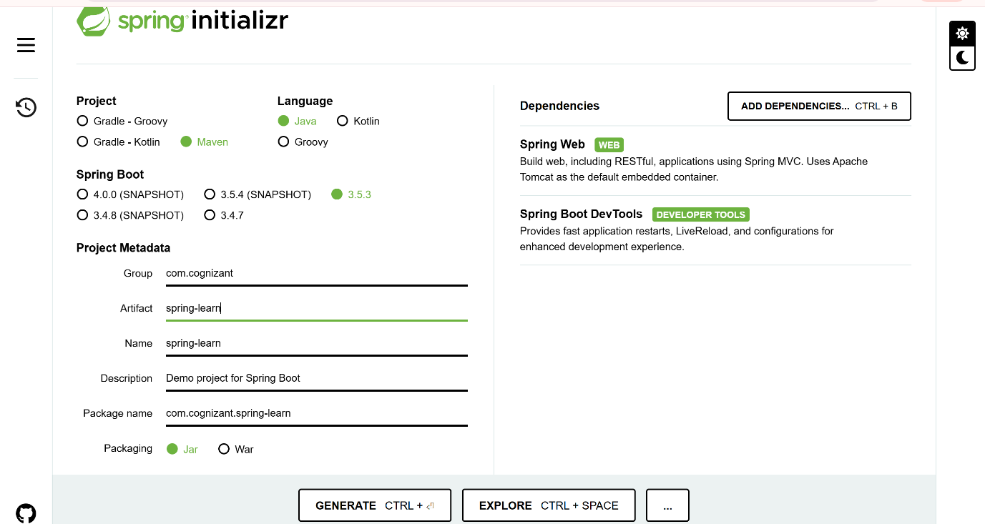

**Step 2 :**

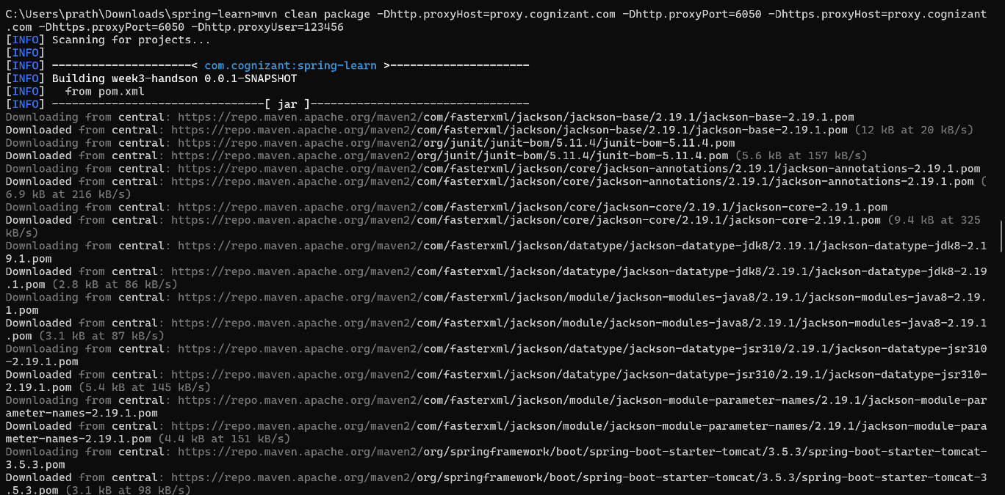

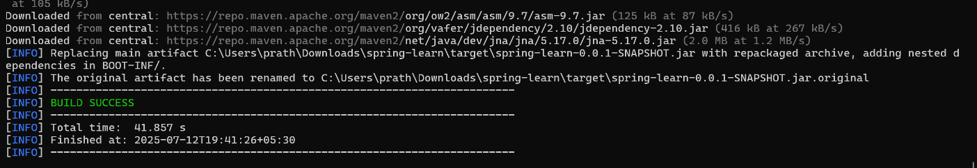

**Pom.xml:**

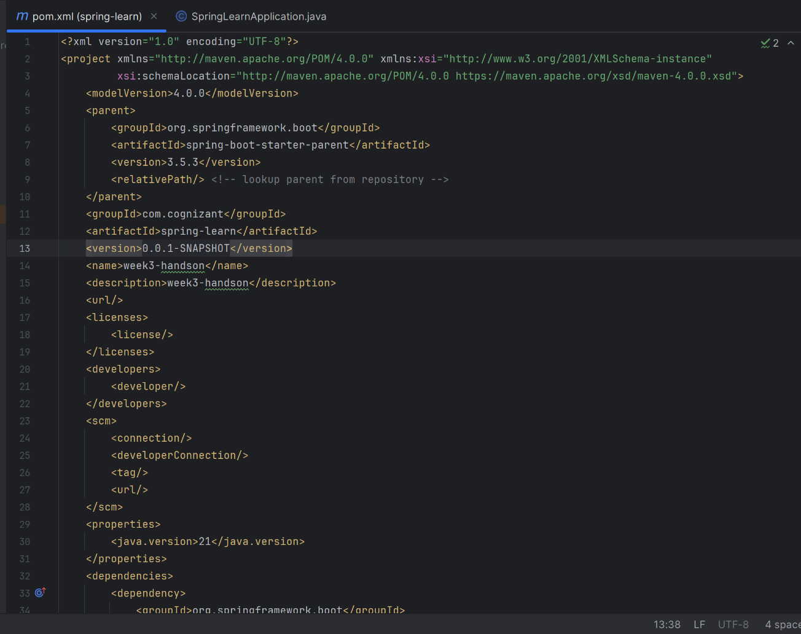

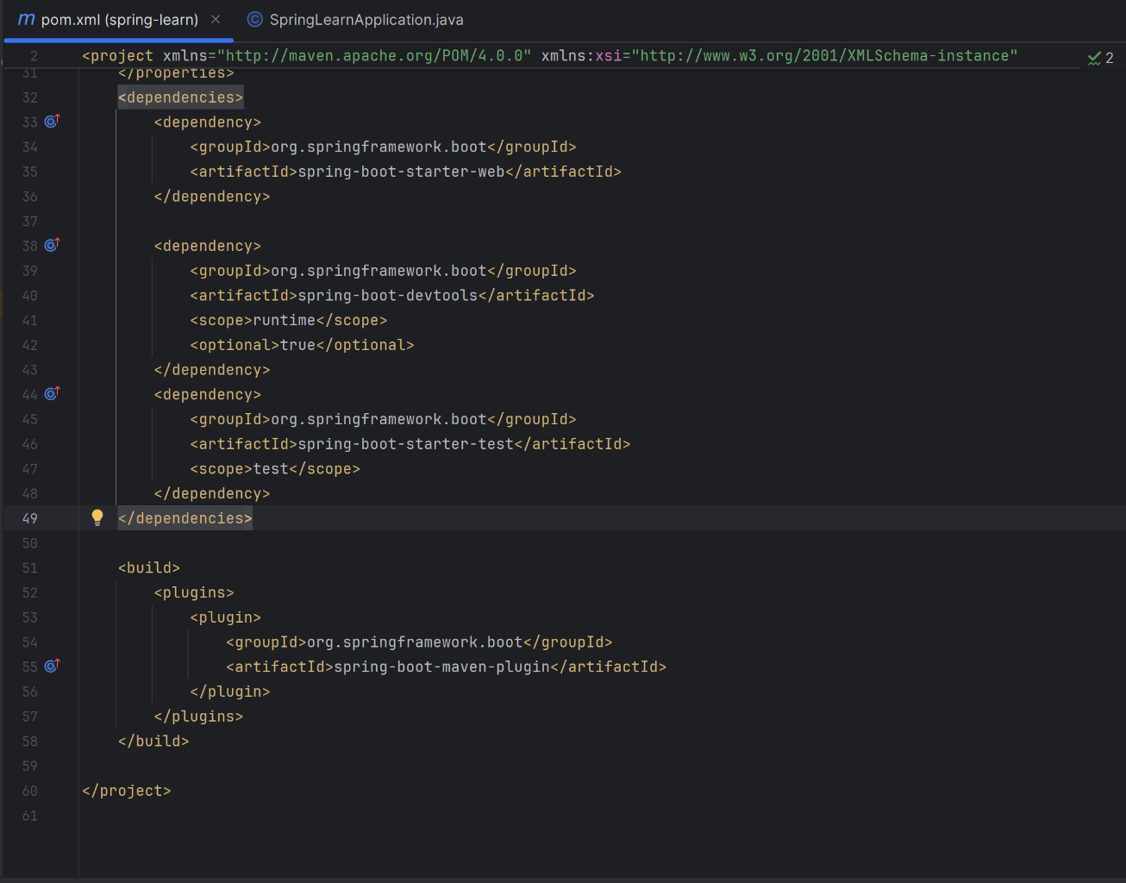

**SpringApplication.java:**  
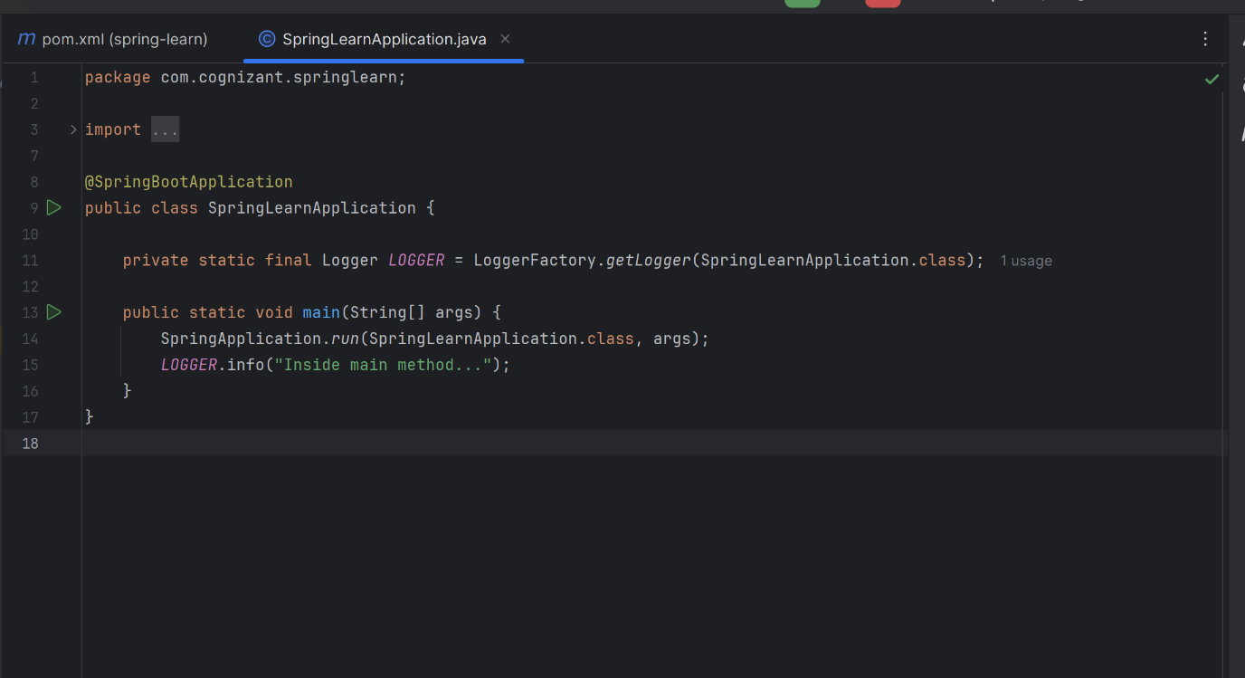

**OUTPUT :  
  
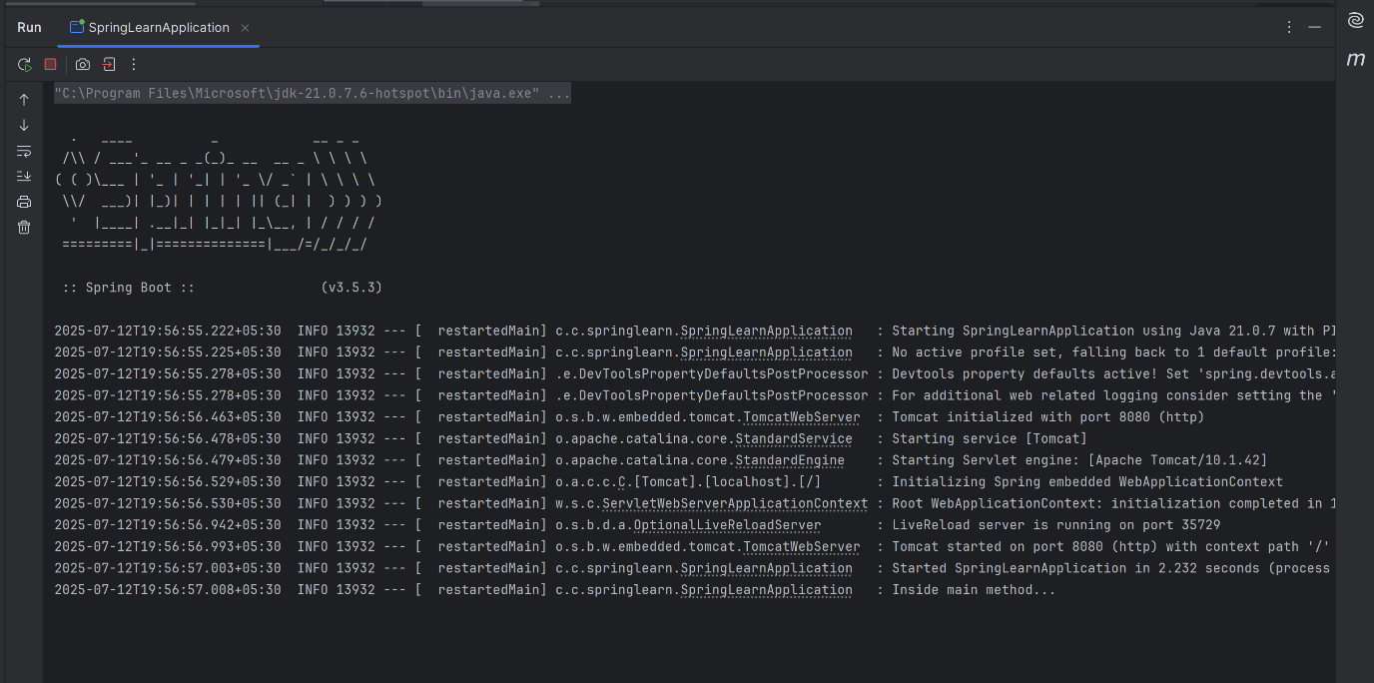**

**Project Structure:**

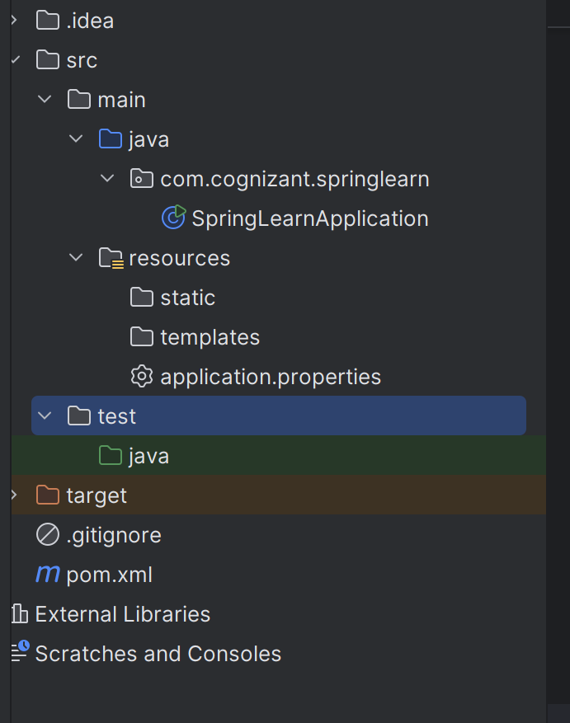

1. src/main/java: Contains all Java application source code.
2. src/main/resources: Contains configuration files like application.properties.
3. src/test/java: Reserved for unit and integration testing.
4. SpringLearnApplication.java:
   * This is the main entry point.
   * Annotated with @SpringBootApplication, it initializes the Spring context.
   * Log message added to confirm execution.
5. @SpringBootApplication Annotation:
   * Combines @Configuration, @EnableAutoConfiguration, and @ComponentScan
   * Enables Spring Boot’s auto-configuration and component scanning.
6. pom.xml Walkthrough:
   * Contains all Maven configurations and dependencies.
   * Defined spring-boot-starter-web and spring-boot-devtools
   * Shows project metadata (groupId, artifactId, version)
7. Dependency Hierarchy:
   * Opened in IntelliJ to view all transitive dependencies.
   * Noted that spring-boot-starter-web brings in:
     + Tomcat (embedded server)
     + Jackson (for JSON)
     + Spring MVC modules

**2.Spring Core – Load Country from Spring Configuration XML**

**Date-format.xml:  
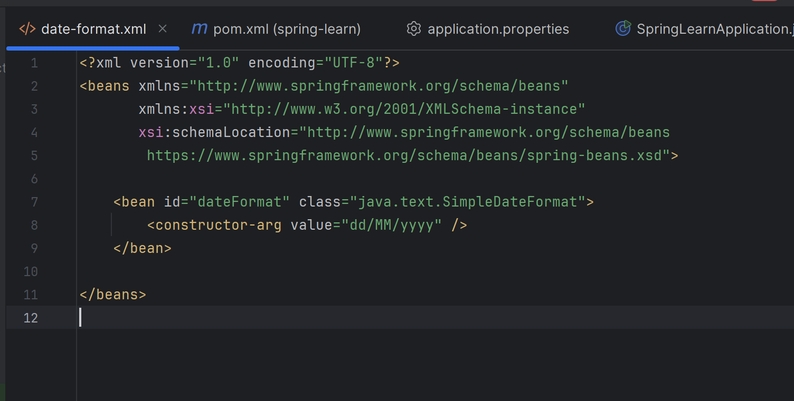**

**application.properties:  
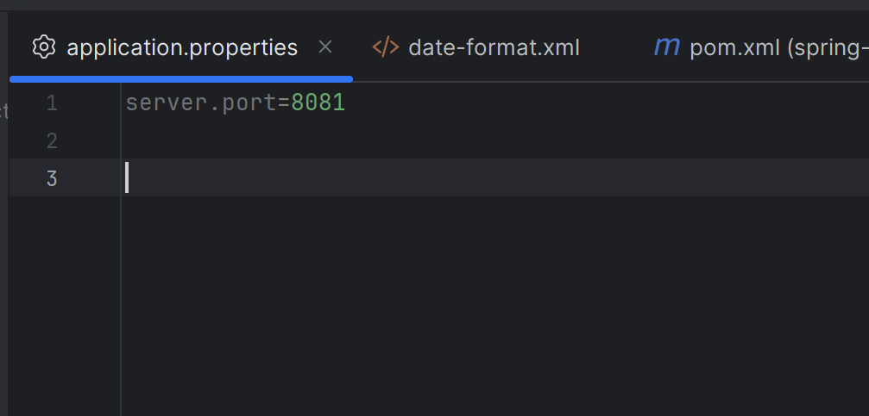**

**SpringApplication.java :**

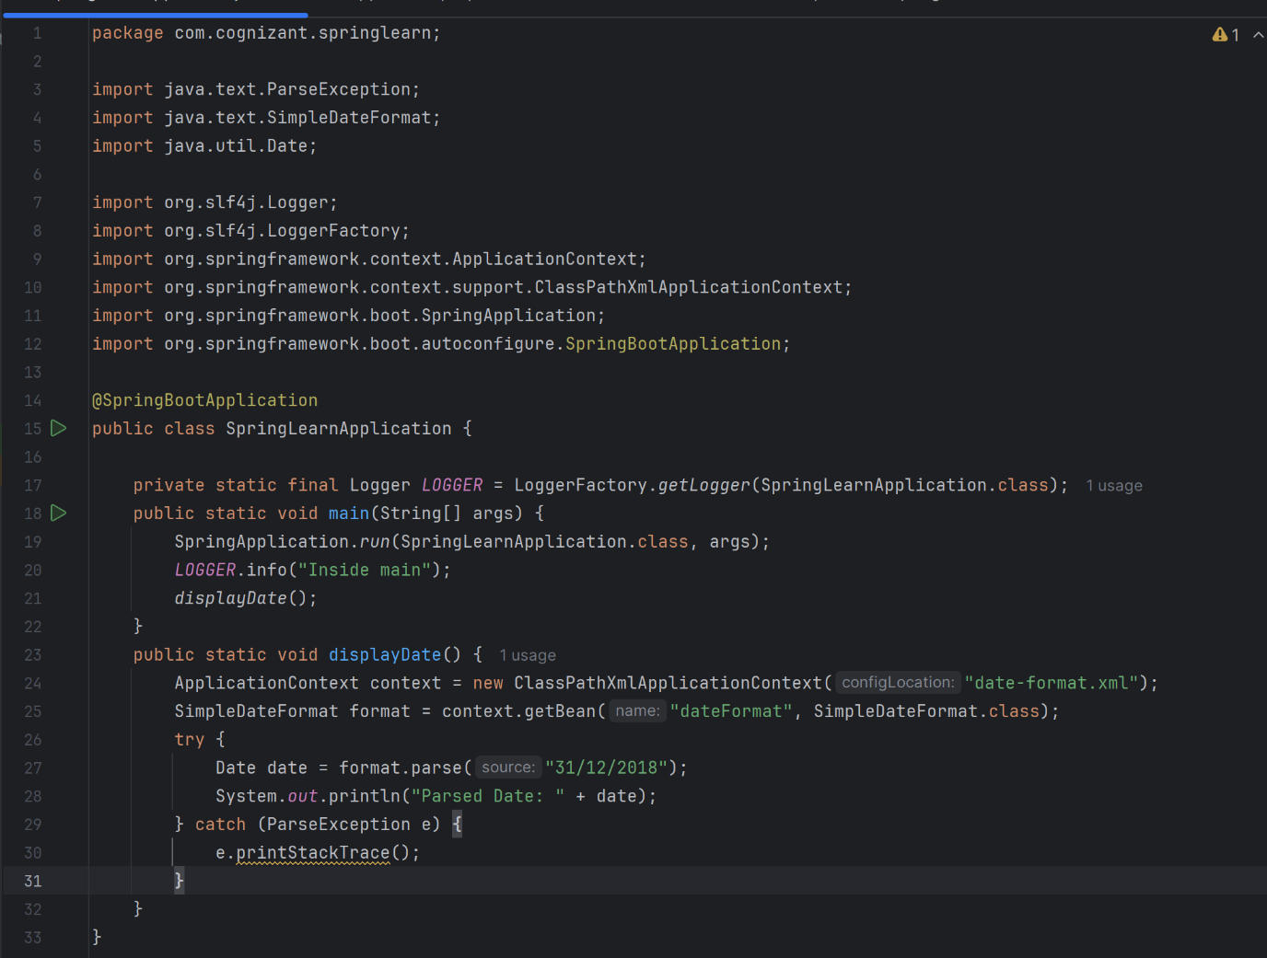

**Output:  
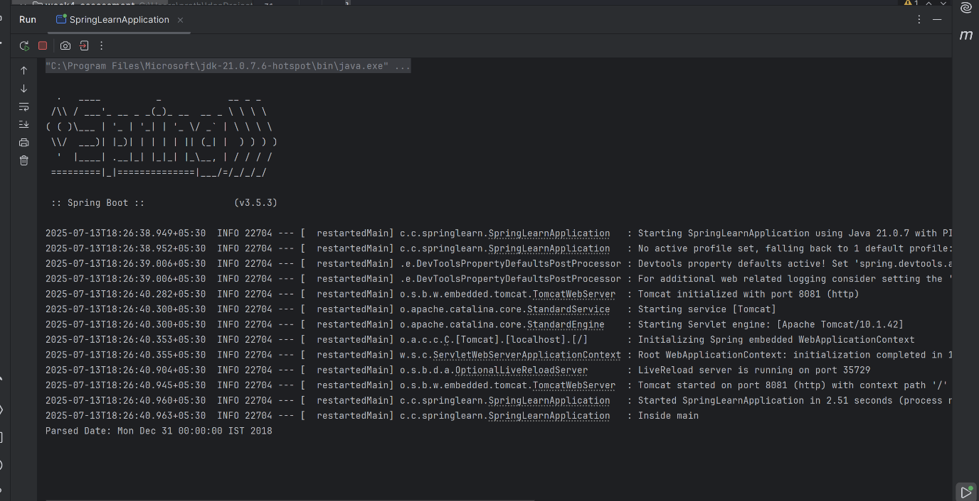**

**3.Hello World RESTful Web Service :  
  
HelloController:  
  
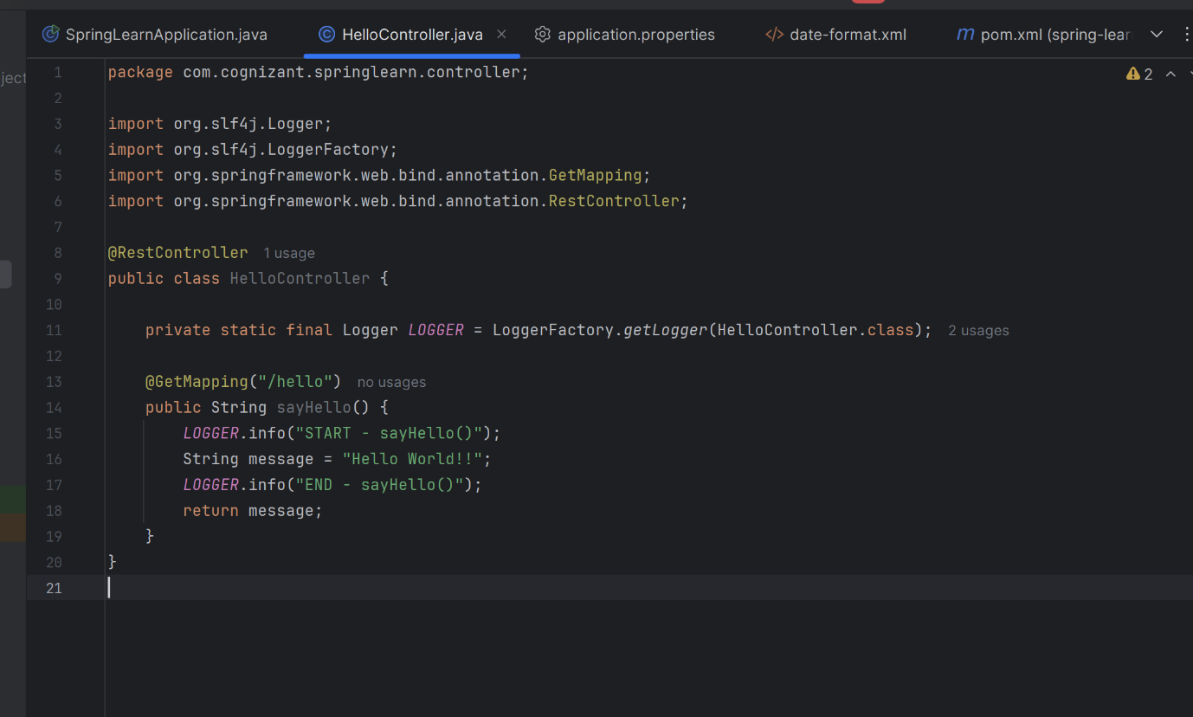**

**Application.properties:  
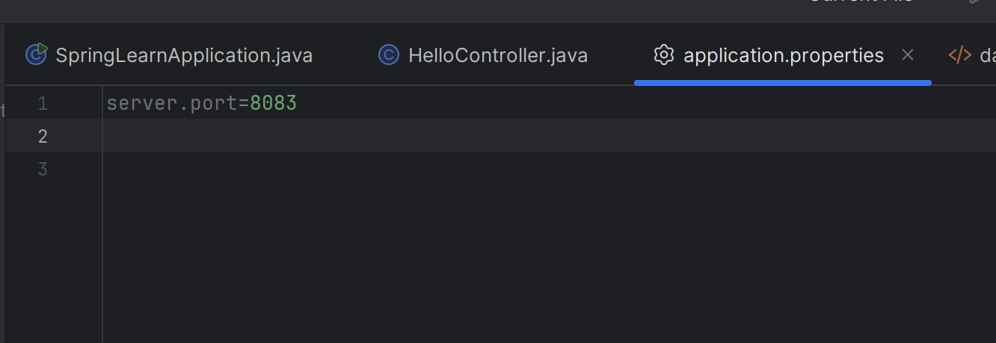**

**SpringLearnApplication.java :  
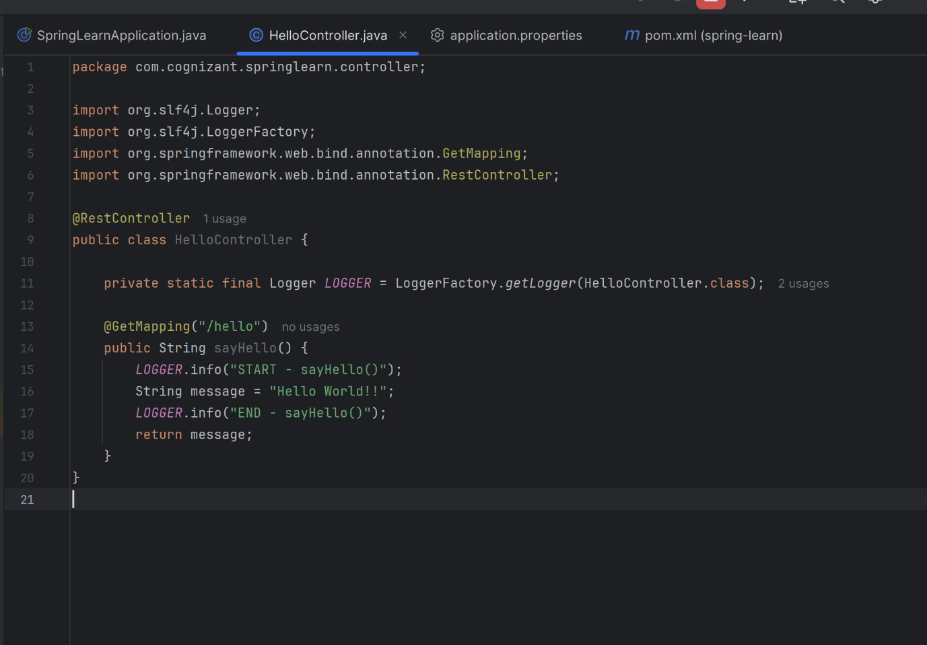**

**Output:  
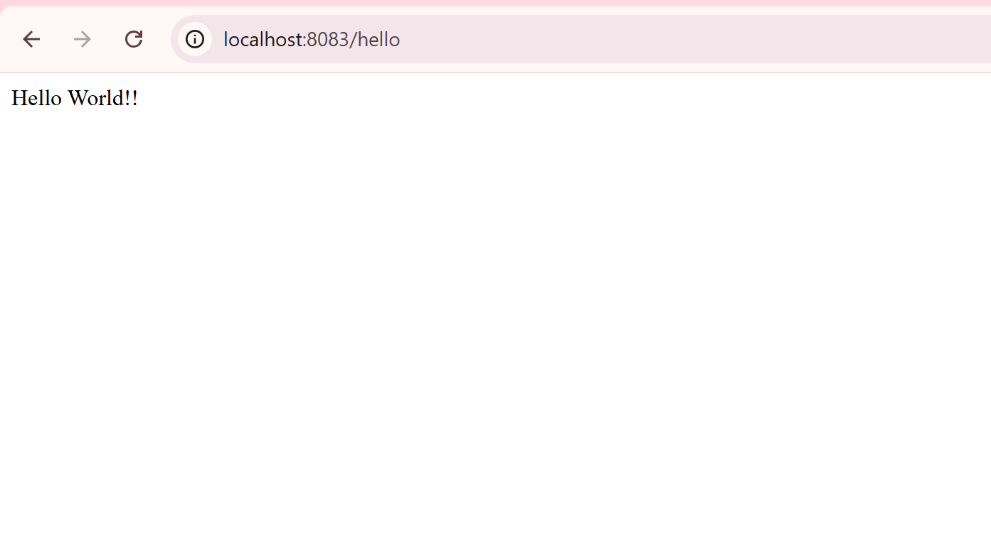**

**Checking using postman:  
  
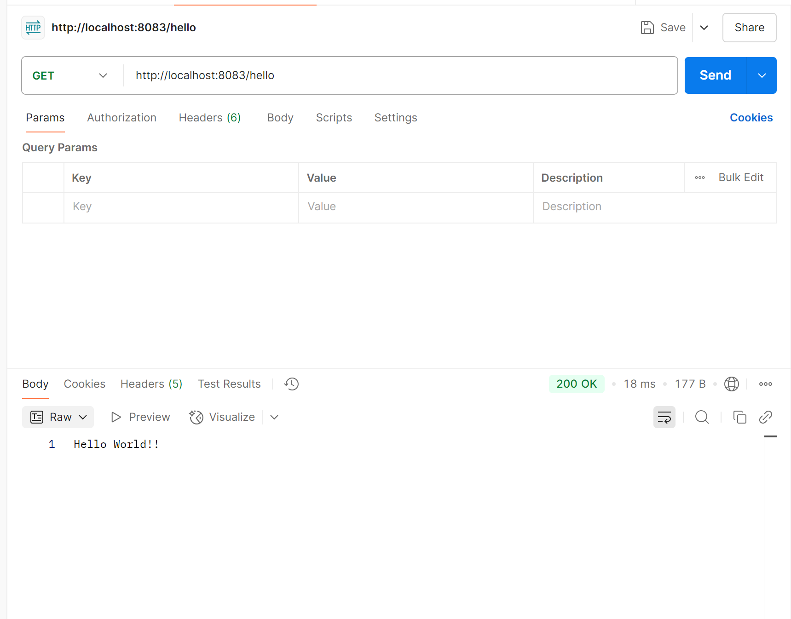**

**Header:  
  
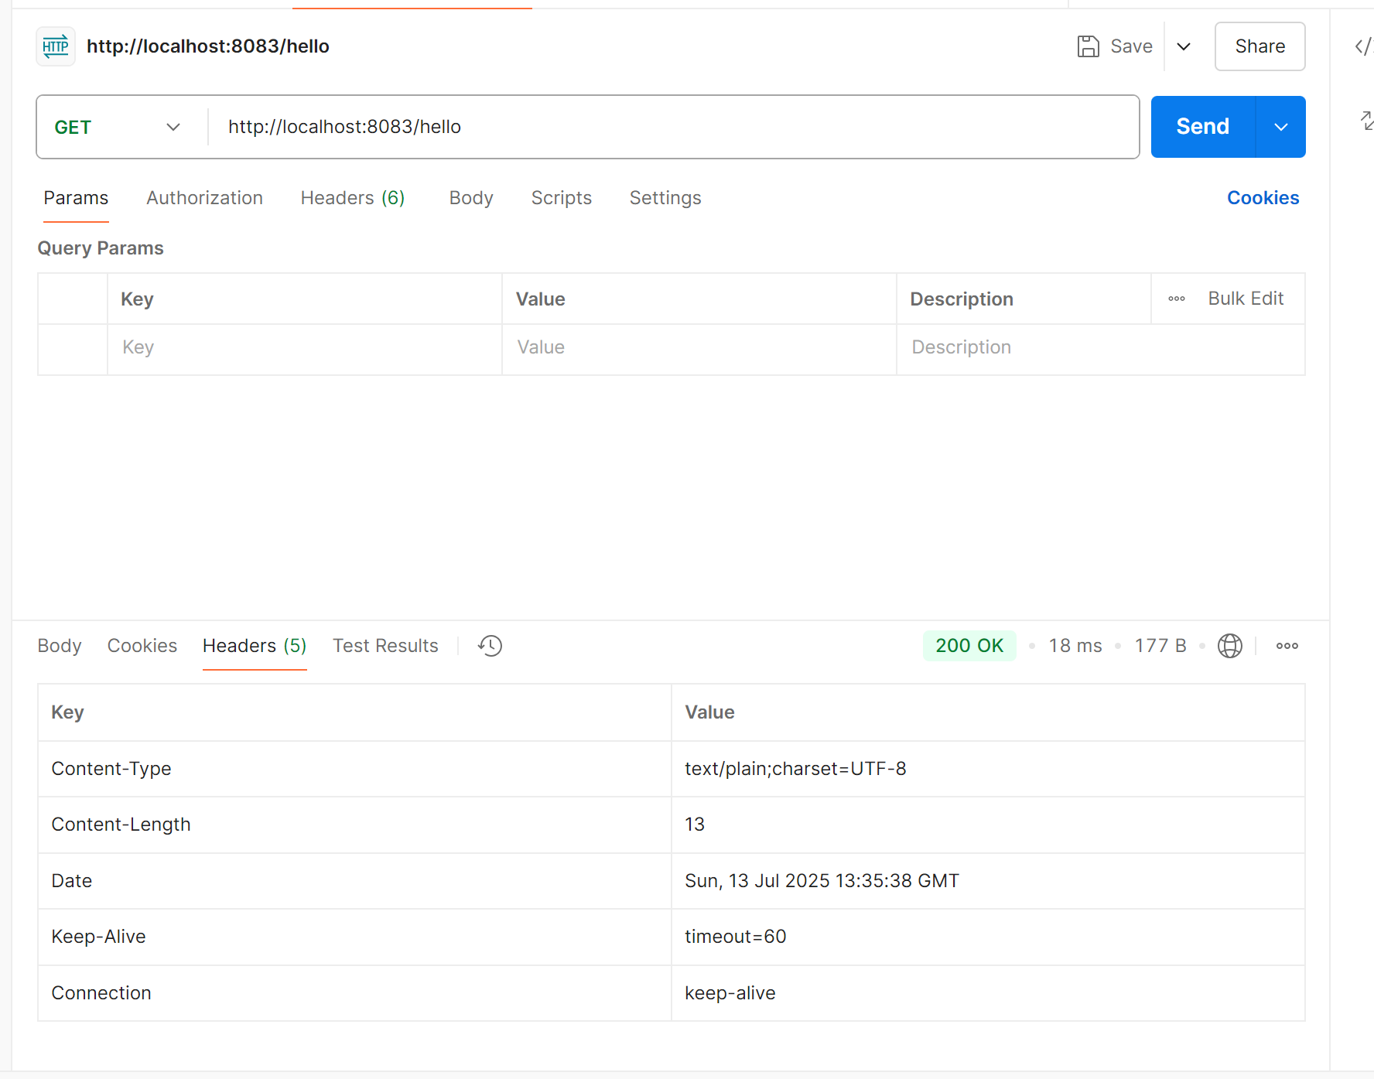**

**4.REST-Country Web Service:**

**Model/country :  
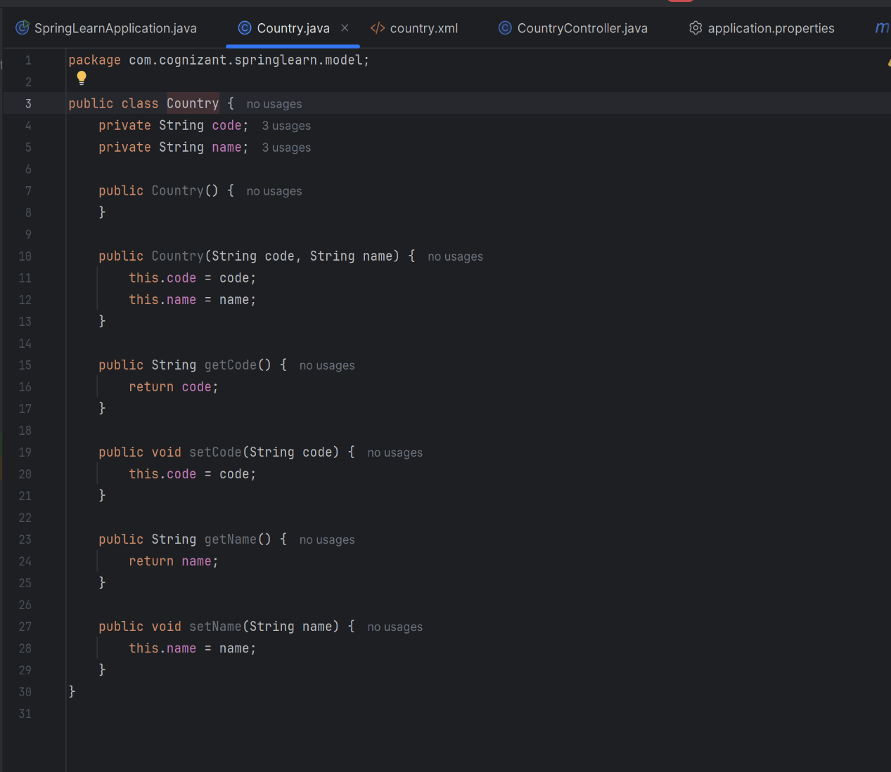**

**CountryController.java :**

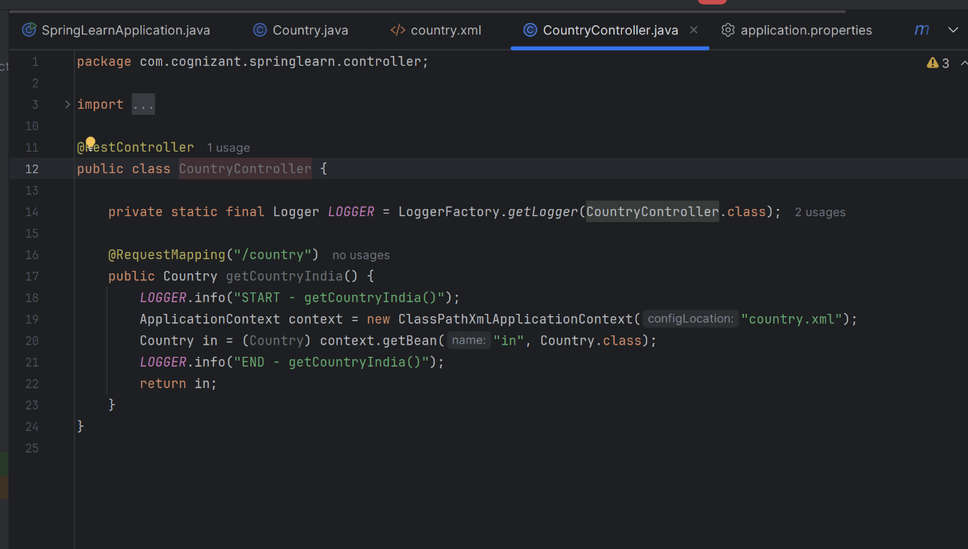

**Country.xml:  
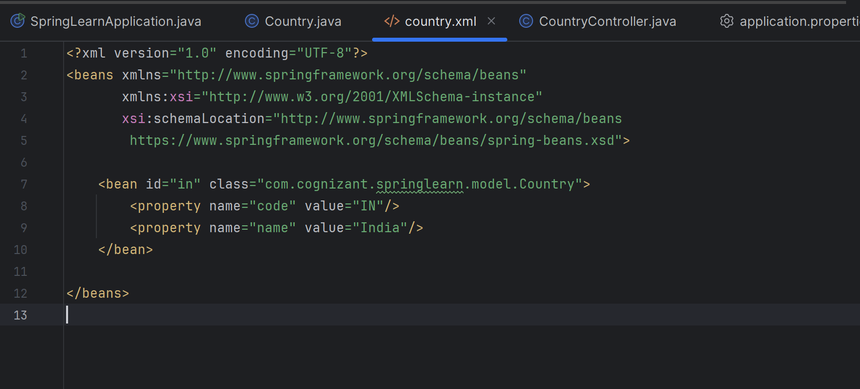**

**SpringLearnApplication.java:**

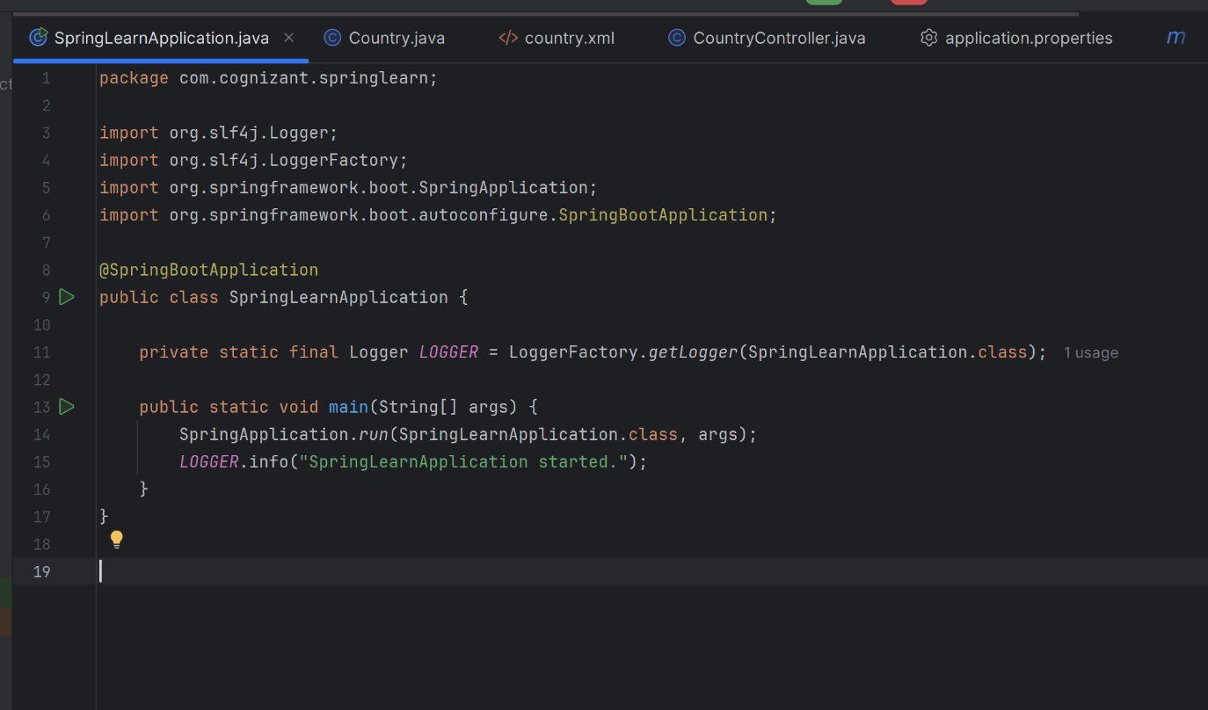

**Output:  
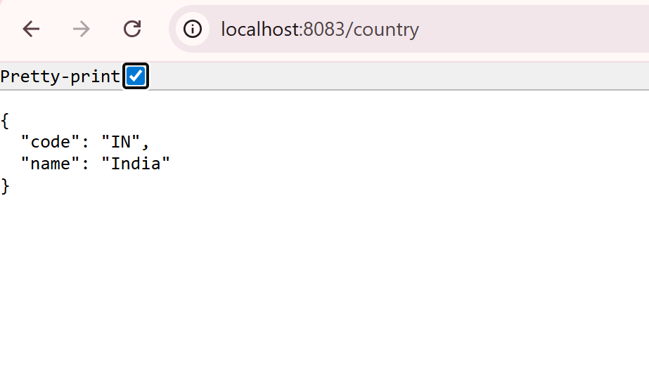**

**Postman output:  
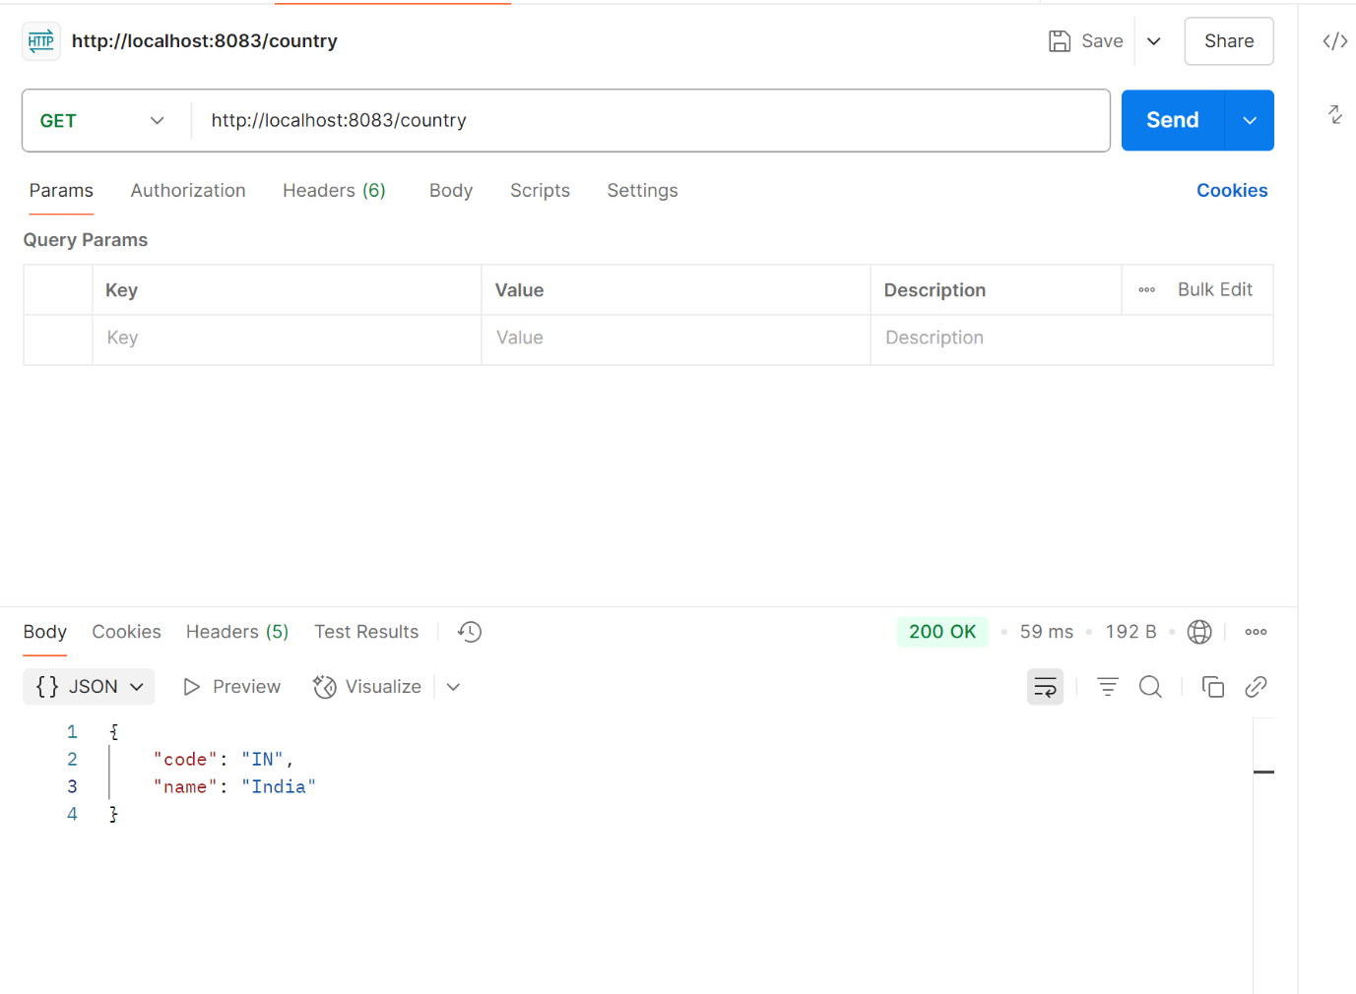**

**Header:  
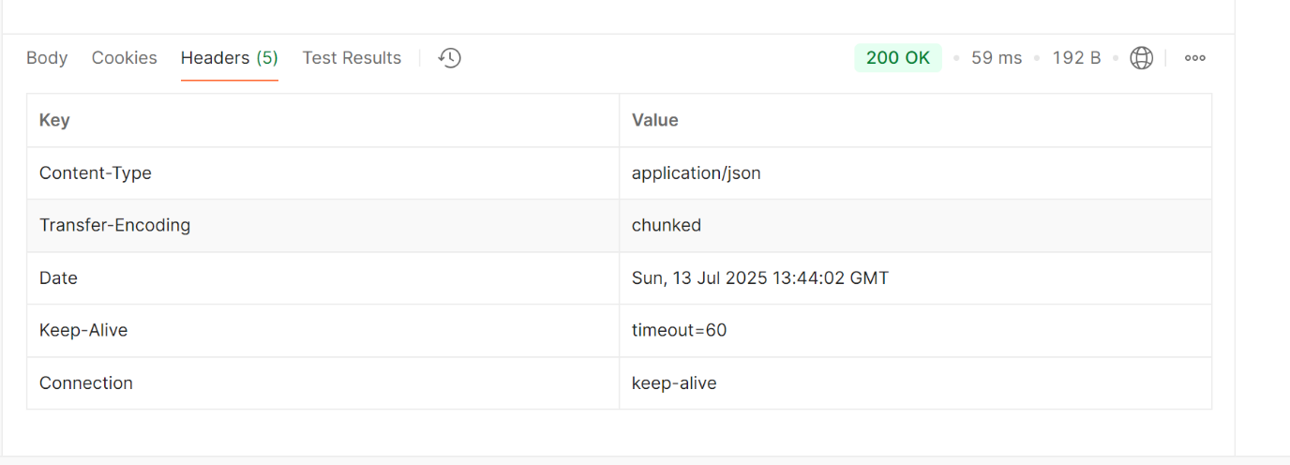**Controller Method :

* @RequestMapping("/country") handles GET requests to /country
* getCountryIndia() loads the Spring XML context
* Gets the in bean of type Country
* Returns it to Spring, which serializes it to JSON using Jackson

Bean Converted to JSON :

Spring Boot includes Jackson (via spring-boot-starter-web) which:

* Converts any object returned from a controller into JSON
* This is done by the built-in MappingJackson2HttpMessageConverter

So, returning a Country object automatically gives:

{

"code": "IN",

"name": "India"

}

**5.REST-Get Country based on country code:**

**CountryController :**

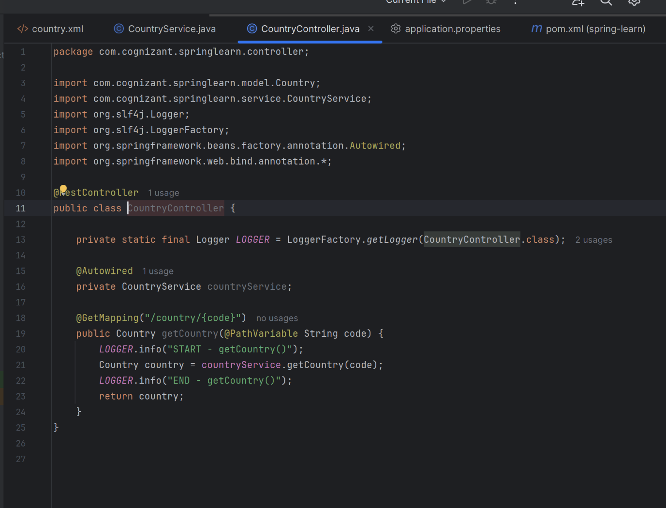

**Model/Country :**

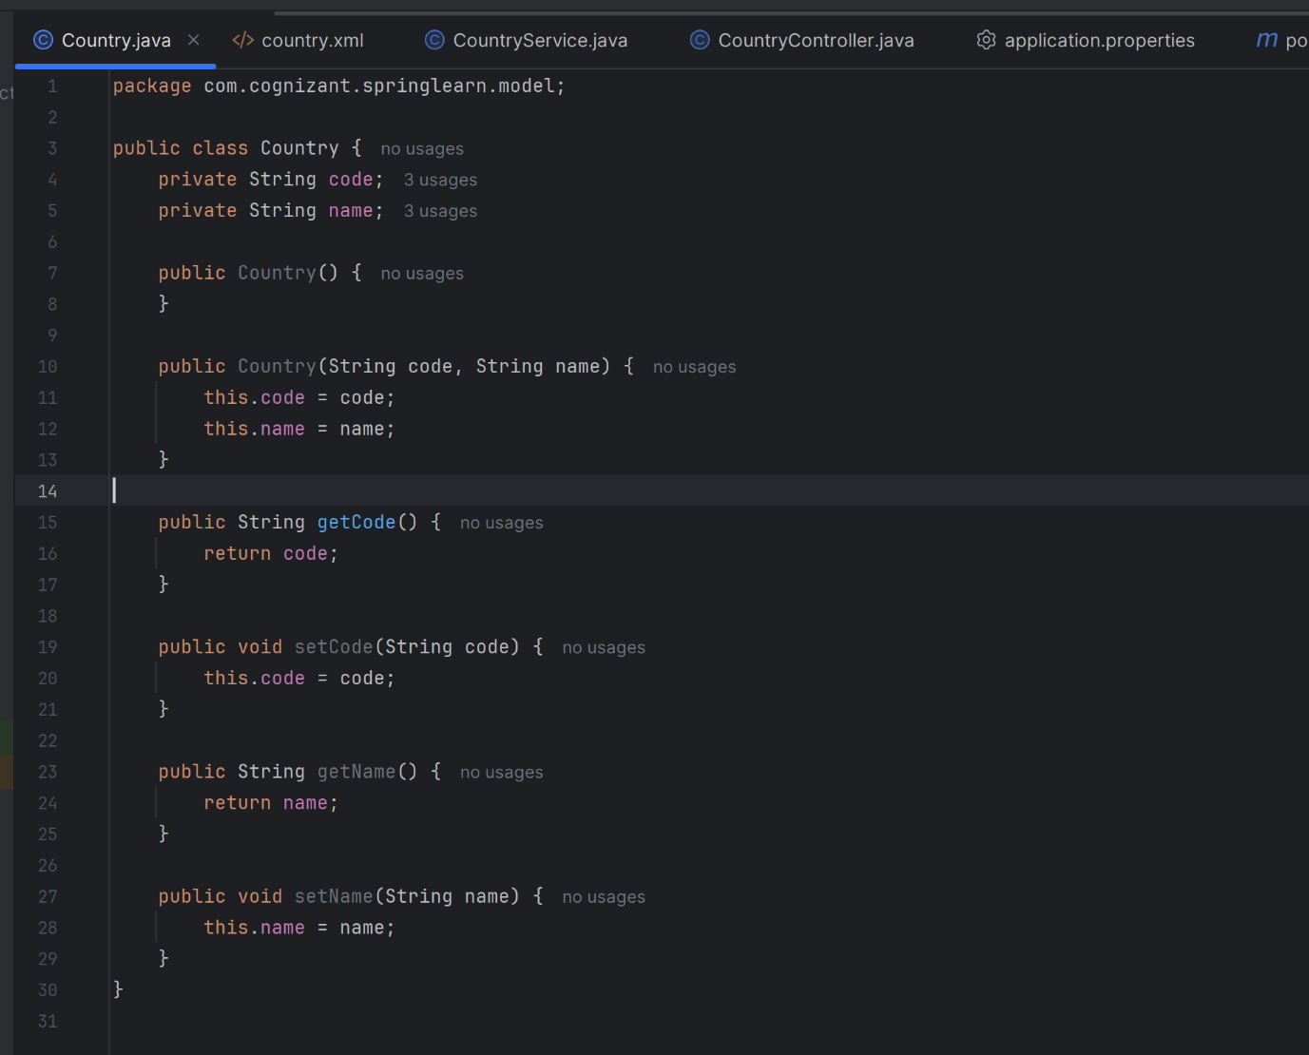

**CountryService:**

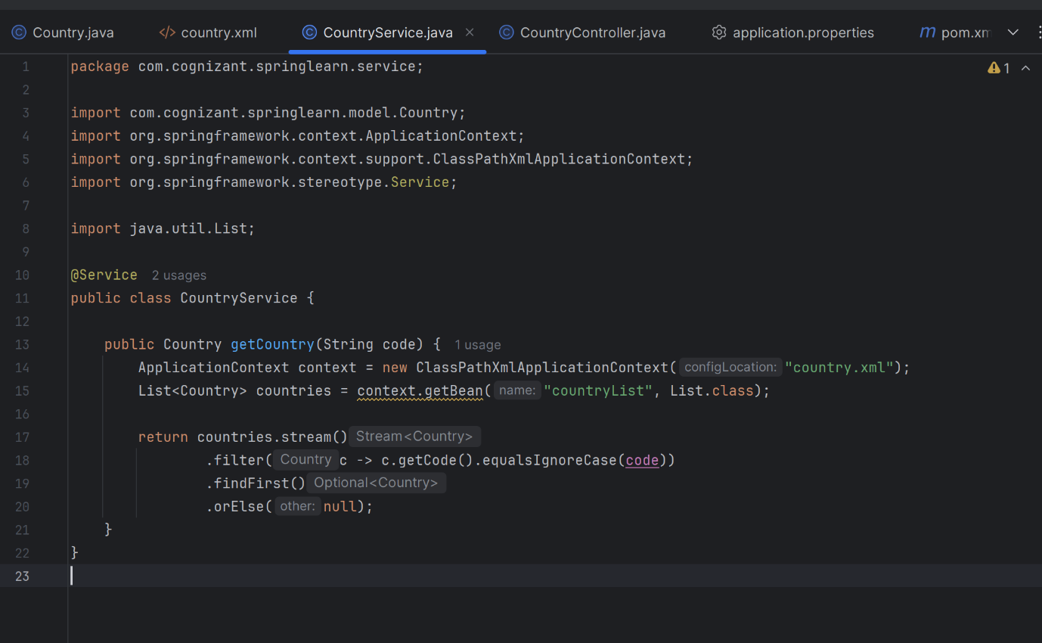

**Country.xml:  
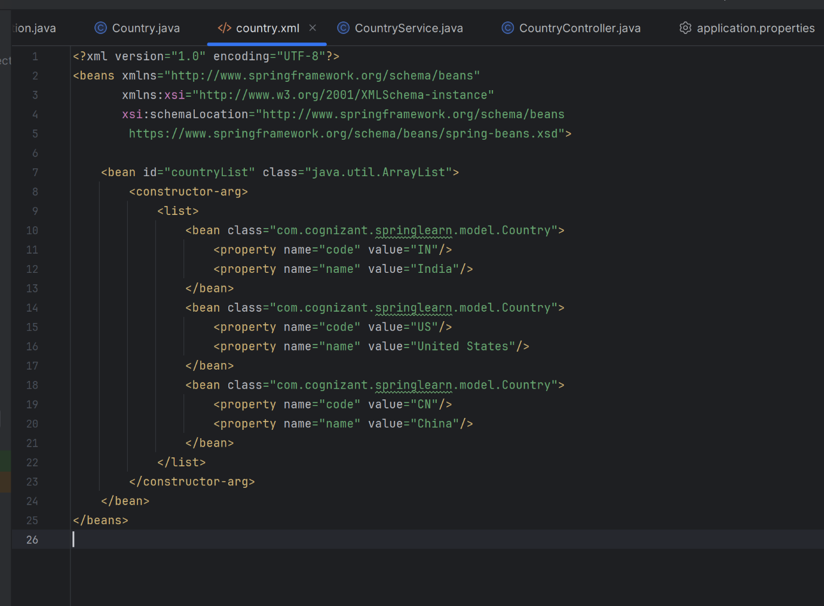**

**Output:  
  
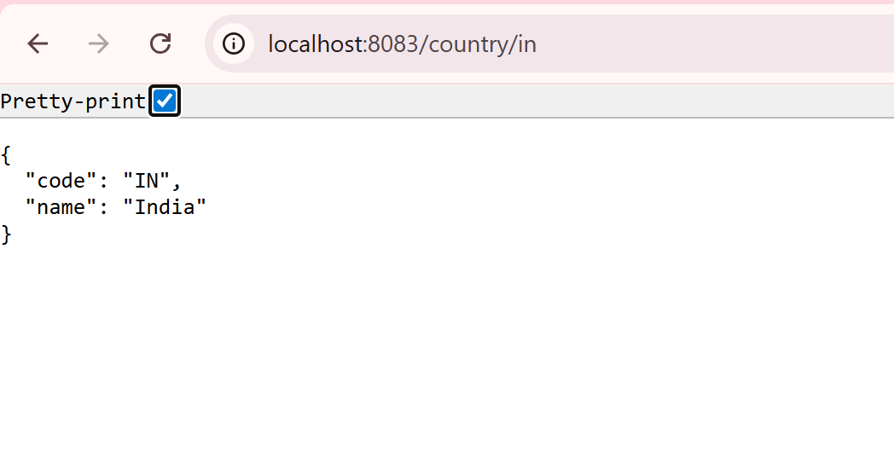**

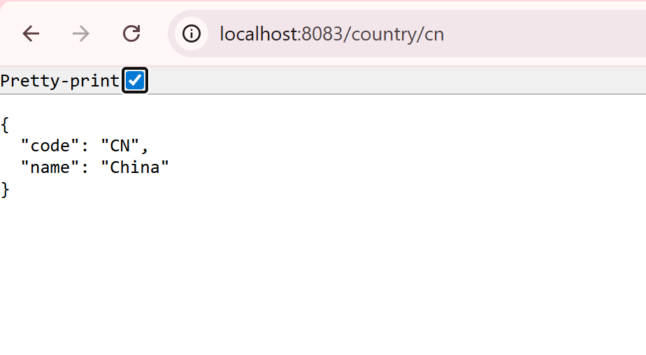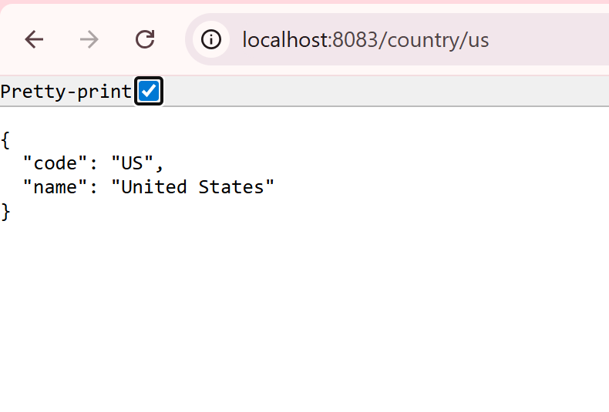

**Headers:**

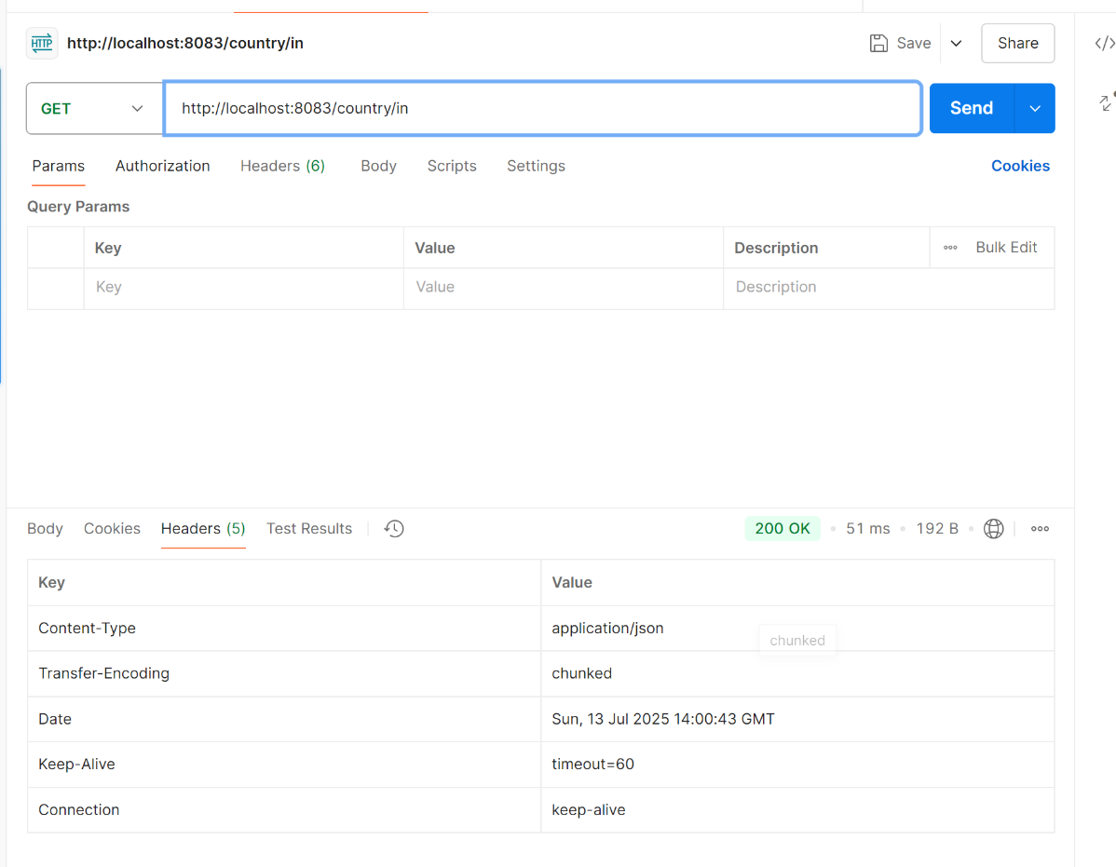

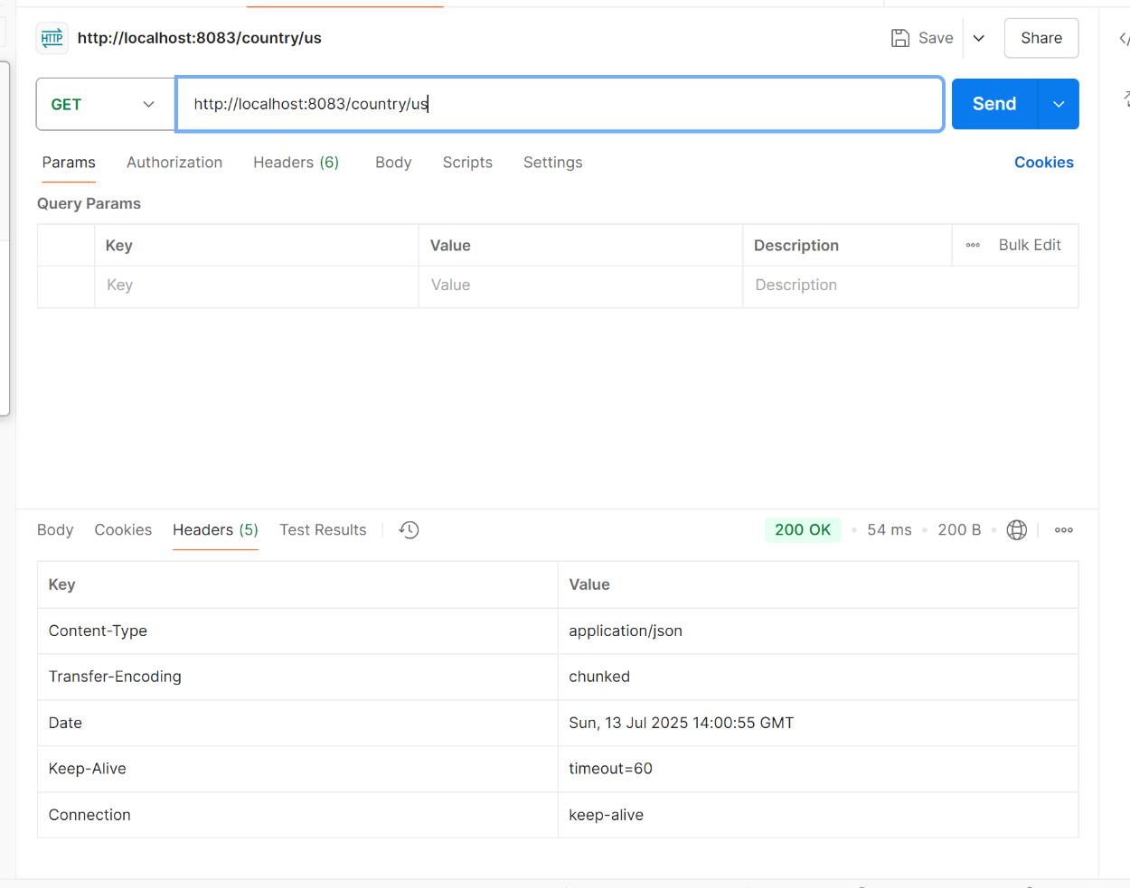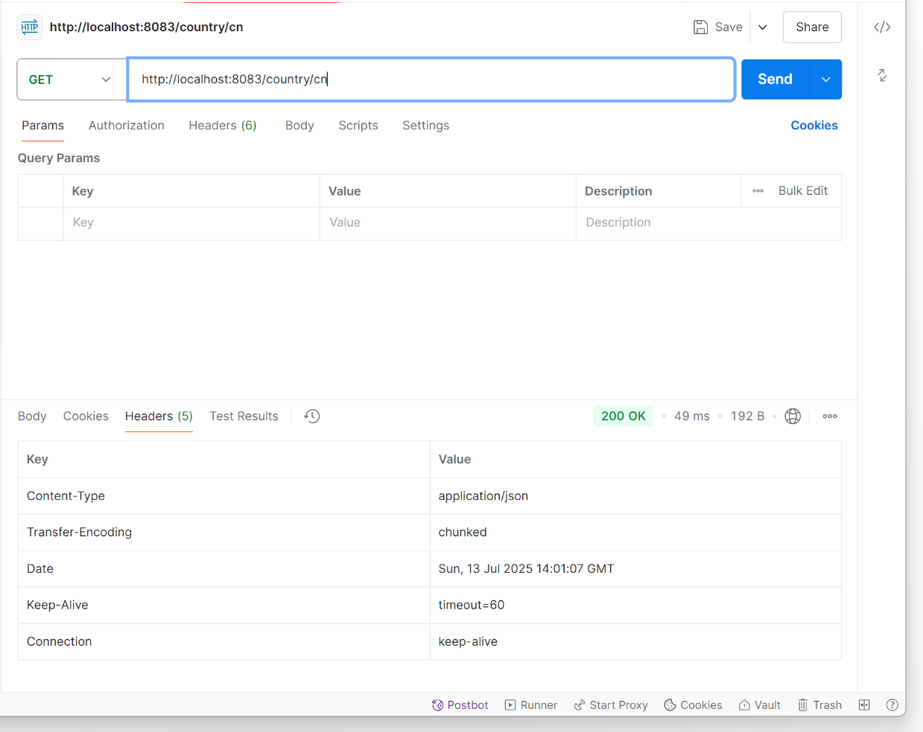

**6.Create authentication service that returns JWT:**

**SecurityConfig:  
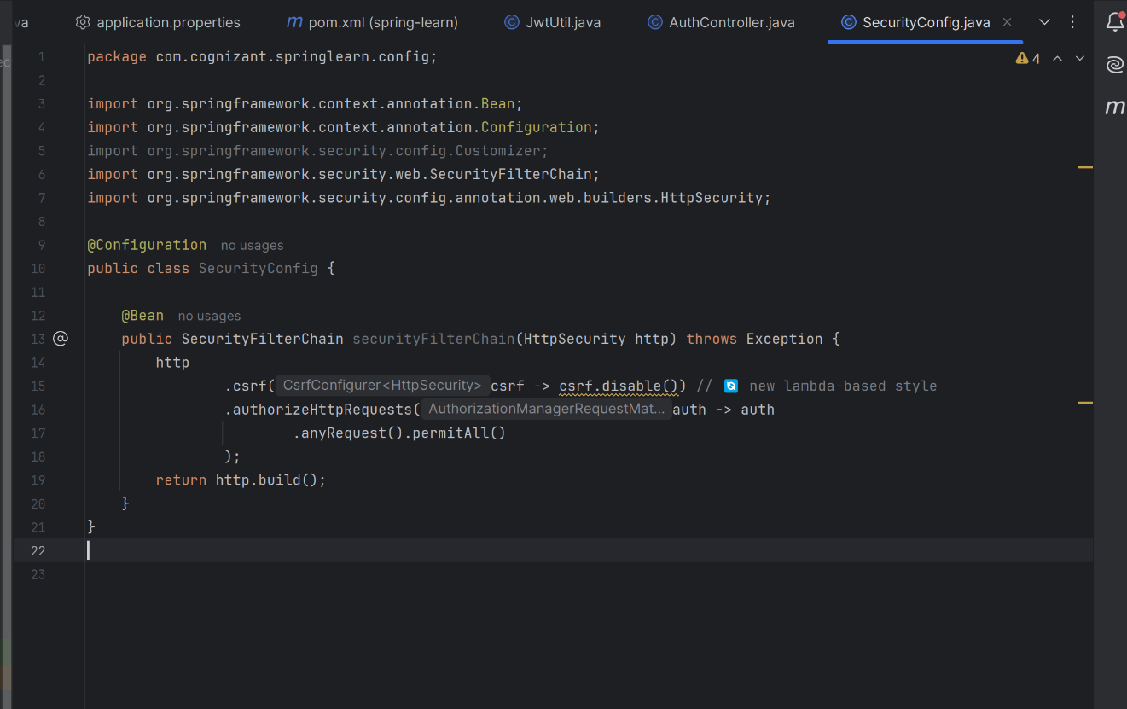**

**AuthController.java:**

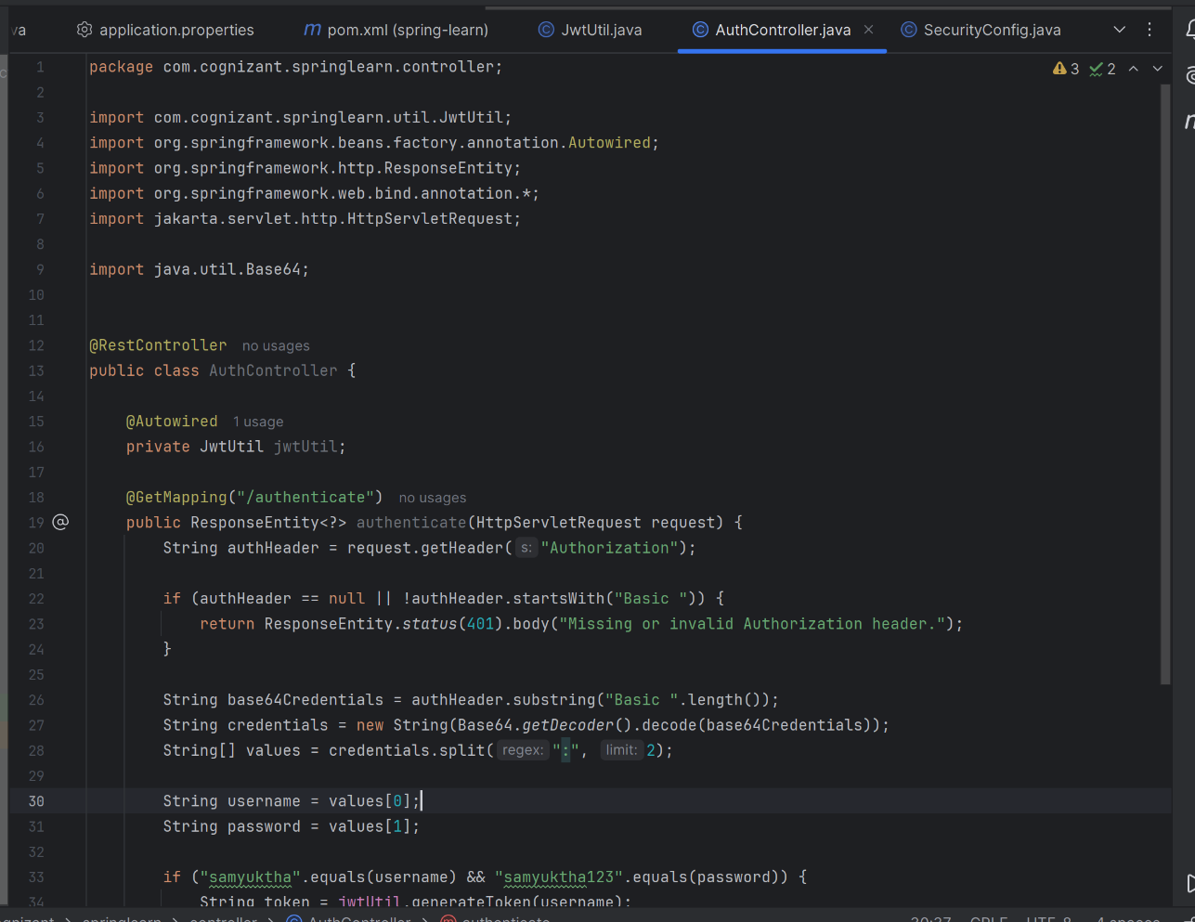

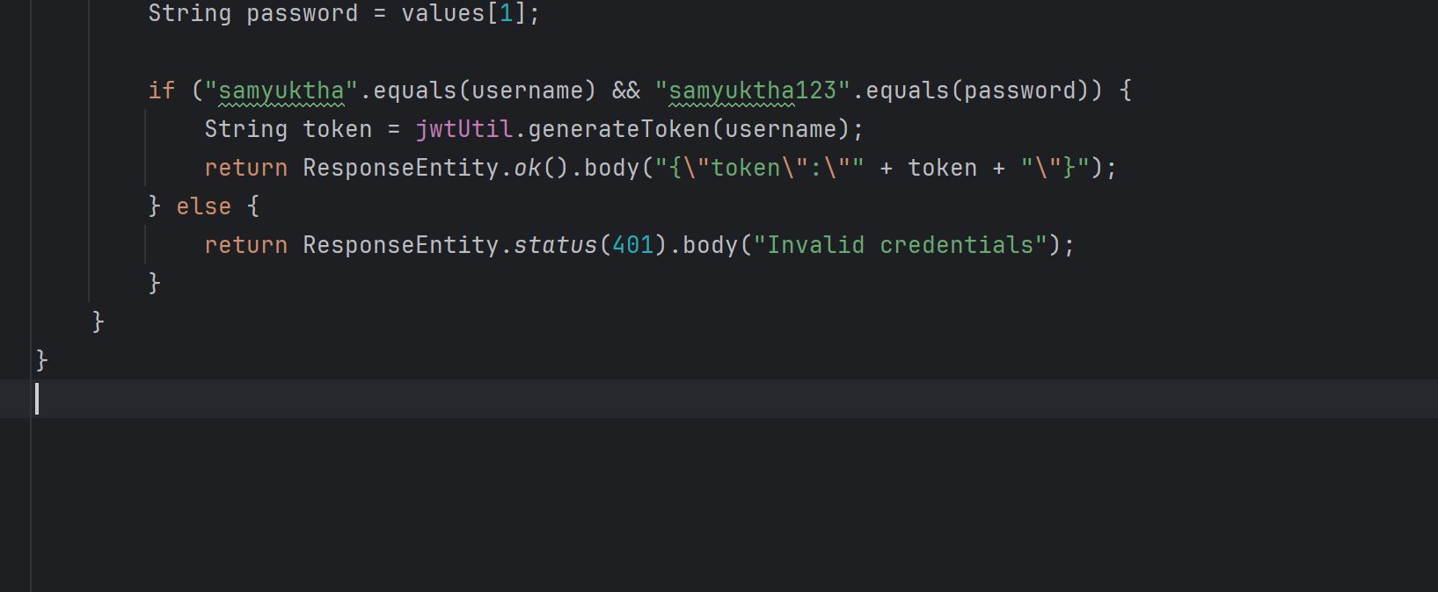

**JwtUtil.java:**

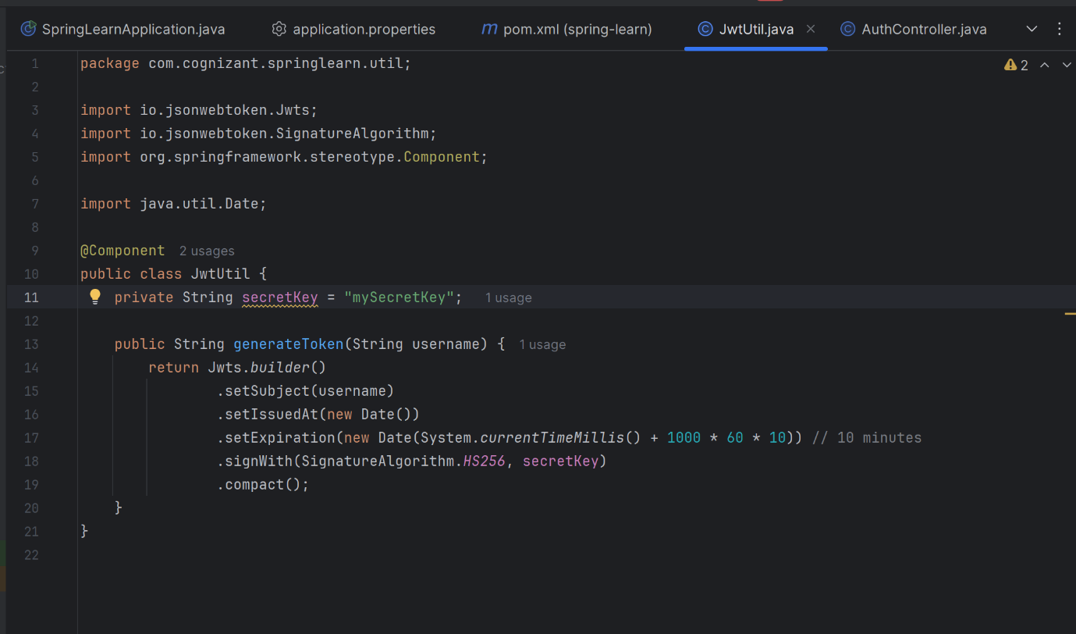

**Output:  
**

**Postman output:  
